**1. Create a new component which has a news title (should print as h2), news details(<p>), published date, source. Create this component using a sling model.**

Component Path: /apps/news/components/news

**news.html**

<div class="news-component">

<h2>${properties.newsTitle}</h2>

<p>${properties.newsDetails}</p>

<p>Source: ${properties.newsSource}</p>

<p>${properties.publishedDate}</p>

</div>

**NewsModel.java**

package com.news.core.models;

import org.apache.sling.api.resource.Resource;

import org.apache.sling.models.annotations.DefaultInjectionStrategy;

import org.apache.sling.models.annotations.Model;

import org.apache.sling.models.annotations.injectorspecific.ValueMapValue;

@Model(adaptables = Resource.class, defaultInjectionStrategy = DefaultInjectionStrategy.OPTIONAL)

public class NewsModel {

@ValueMapValue

private String newsTitle;

@ValueMapValue

private String newsDetails;

@ValueMapValue

private String publishedDate;

@ValueMapValue

private String newsSource;

public String getNewsTitle() {

return newsTitle;

}

public String getNewsDetails() {

return newsDetails;

}

public String getNewsSource() {

return newsSource;

}

public String getPublishedDate() {

return publishedDate;

}

}

**dialog.xml**

<jcr:root xmlns:jcr="http://www.jcp.org/jcr/1.0"

xmlns:sling="http://sling.apache.org/jcr/sling/1.0"

xmlns:cq="http://www.day.com/jcr/cq/1.0"

jcr:primaryType="cq:Dialog"

cq:dialogMode="floating">

<content jcr:primaryType="nt:unstructured">

<items jcr:primaryType="nt:unstructured">

<newsTitle

jcr:primaryType="nt:unstructured"

sling:resourceType="granite/ui/components/coral/foundation/form/textfield"

fieldLabel="News Title"

name="./newsTitle"/>

<newsDetails

jcr:primaryType="nt:unstructured"

sling:resourceType="granite/ui/components/coral/foundation/form/textarea"

fieldLabel="News Details"

name="./newsDetails"/>

<newsSource

jcr:primaryType="nt:unstructured"

sling:resourceType="granite/ui/components/coral/foundation/form/textfield"

fieldLabel="Source"

name="./newsSource"/>

<publishedDate

jcr:primaryType="nt:unstructured"

sling:resourceType="granite/ui/components/coral/foundation/form/textfield"

fieldLabel="Published Date"

name="./publishedDate"/>

</items>

</content>

</jcr:root>

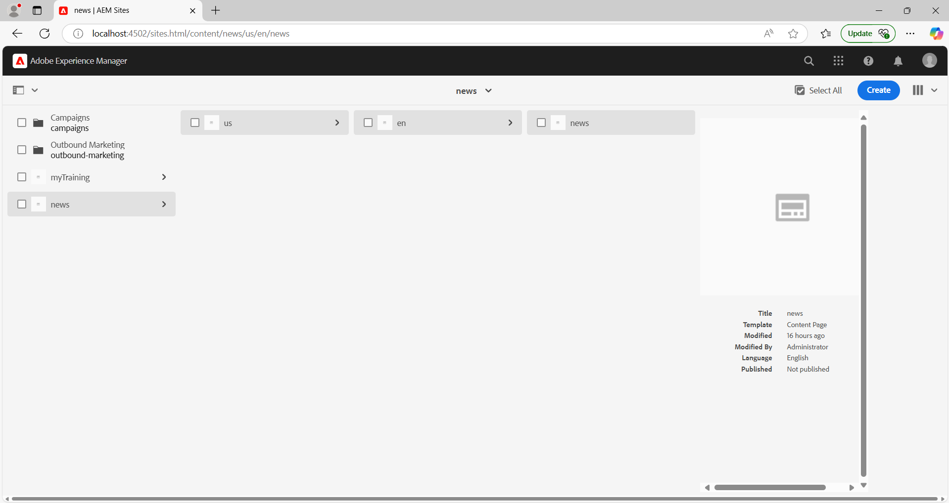

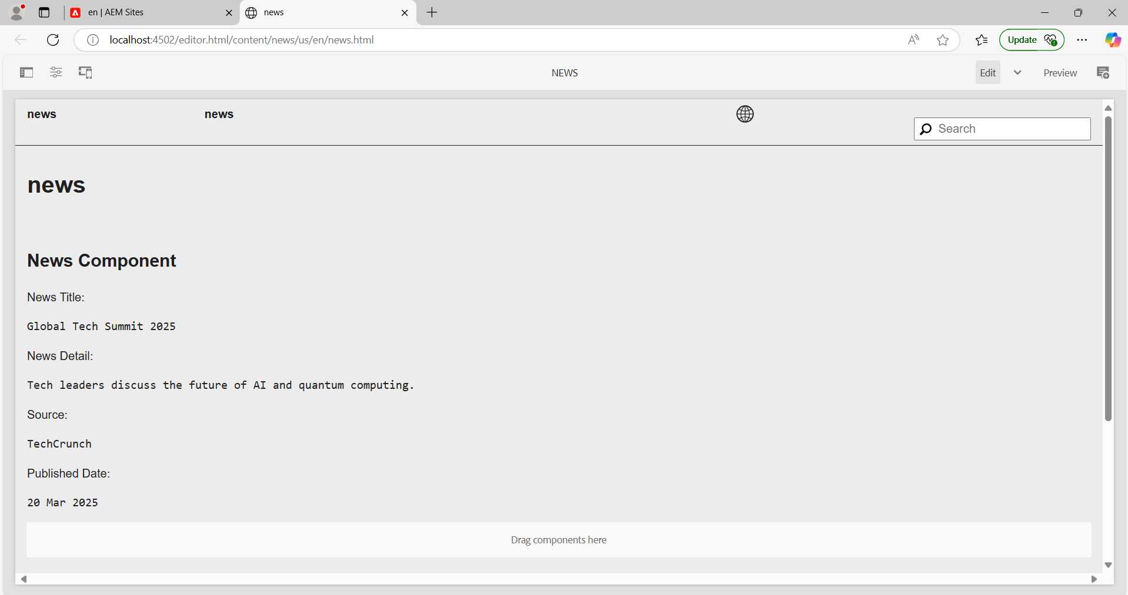

**2. Create multi-field component (multiple news) using sling model fields: title of news and source of news.**

Component Path: /apps/news/components/multinews

**multinews.html**

<div data-sly-use.newsModel="com.news.core.models.MultiNewsModel">

<div data-sly-list.newsItem="${newsModel.newsList}">

<h2>${newsItem.title}</h2>

<p>Source: ${newsItem.source}</p>

</div>

</div>

**MultiNewsModel.java**

package com.news.core.models;

import org.apache.sling.api.resource.Resource;

import org.apache.sling.models.annotations.DefaultInjectionStrategy;

import org.apache.sling.models.annotations.Model;

import org.apache.sling.models.annotations.injectorspecific.ChildResource;

import java.util.List;

@Model(adaptables = Resource.class, defaultInjectionStrategy = DefaultInjectionStrategy.OPTIONAL)

public class MultiNewsModel {

@ChildResource

private List<NewsItem> newsList;

public List<NewsItem> getNewsList() {

return newsList;

}

public static class NewsItem {

@ValueMapValue

private String title;

@ValueMapValue

private String source;

public String getTitle() {

return title;

}

public String getSource() {

return source;

}

}

}

**dialog.xml**

<jcr:root xmlns:jcr="http://www.jcp.org/jcr/1.0"

xmlns:sling="http://sling.apache.org/jcr/sling/1.0"

xmlns:cq="http://www.day.com/jcr/cq/1.0"

jcr:primaryType="cq:Dialog"

cq:dialogMode="floating">

<content jcr:primaryType="nt:unstructured">

<items jcr:primaryType="nt:unstructured">

<multifield

jcr:primaryType="nt:unstructured"

sling:resourceType="granite/ui/components/coral/foundation/form/multifield"

fieldLabel="News Items"

name="./newsList">

<field jcr:primaryType="nt:unstructured"

sling:resourceType="granite/ui/components/coral/foundation/form/fieldset">

<items jcr:primaryType="nt:unstructured">

<title

jcr:primaryType="nt:unstructured"

sling:resourceType="granite/ui/components/coral/foundation/form/textfield"

fieldLabel="News Title"

name="./title"/>

<source

jcr:primaryType="nt:unstructured"

sling:resourceType="granite/ui/components/coral/foundation/form/textfield"

fieldLabel="Source"

name="./source"/>

</items>

</field>

</multifield>

</items>

</content>

</jcr:root>

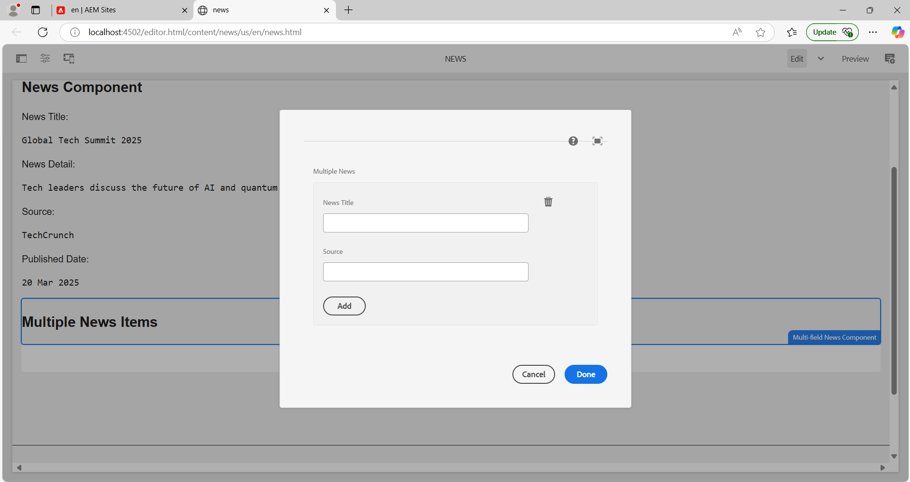

**3. Create clientlibs for the news component.**

Component Path: /apps/news/clientlibs/news

**css.txt**

news.css

**js.txt**

news.js

**news.css**

.news-component h2 {

color: green;

}

.news-component p {

color: yellow;

}

.news-component .date {

color: black;

}

**news.js**

console.log("News Component Loaded");

**4. Apply green color to the heading(h2) and yellow color to news detail(<p>) and date should be in black color.**

**news.css**

.news-component h2 {

color: green;

}

.news-component p {

color: yellow;

}

.news-component .date {

color: black;

}

**5. Add Component style to add a custom style name (cop-news-component) to the news component.**

**.content.xml**

<jcr:root xmlns:jcr="http://www.jcp.org/jcr/1.0"

xmlns:cq="http://www.day.com/jcr/cq/1.0"

jcr:primaryType="cq:Component"

jcr:title="News Component"

componentGroup="Example Components"

cq:style="cop-news-component"/>

**6. Create a base page component and add a new file as metadata so that it can print og:title, og:description and og:image and link this file on the base page.html.**

Component Path: /apps/news/components/basepage

**basepage.html**

<html>

<head>

<link rel="stylesheet" href="/etc.clientlibs/example/clientlibs/news.css" type="text/css">

<meta property="og:title" content="${properties.ogTitle}" />

<meta property="og:description" content="${properties.ogDescription}" />

<meta property="og:image" content="${properties.ogImage}" />

</head>

<body>

<sly data-sly-resource="${'news' @ resourceType='news/components/news'}"></sly>

</body>

</html>

**7. Create custom page properties saying Global properties and three fields should be there as og:title, og :description and og:image path.**

**dialog.xml**

<jcr:root xmlns:jcr="http://www.jcp.org/jcr/1.0"

xmlns:sling="http://sling.apache.org/jcr/sling/1.0"

jcr:primaryType="cq:Dialog"

cq:dialogMode="floating">

<content jcr:primaryType="nt:unstructured">

<items jcr:primaryType="nt:unstructured">

<ogTitle

jcr:primaryType="nt:unstructured"

sling:resourceType="granite/ui/components/coral/foundation/form/textfield"

fieldLabel="OG Title"

name="./ogTitle"/>

<ogDescription

jcr:primaryType="nt:unstructured"

sling:resourceType="granite/ui/components/coral/foundation/form/textarea"

fieldLabel="OG Description"

name="./ogDescription"/>

<ogImage

jcr:primaryType="nt:unstructured"

sling:resourceType="granite/ui/components/coral/foundation/form/textfield"

fieldLabel="OG Image"

name="./ogImage"/>

</items>

</content>

</jcr:root>

**8. What does extraclientlib add to this multi-field component?**

The extraclientlib property adds additional client libraries (CSS, JS) to the multi-field component, allowing custom styling and JavaScript logic.